Generate Motion Profile Trajectory using Eclipse

FRC Team 3654

1/20/2018

This document describes how to use Eclipse to generate the motion profile trajectory file using Jaci’s Pathfinder library. It assumes the user has no experience in Eclipse. The motion profile trajectory file is needed to control the robot to move at the specified path defined in the trajectory file.

1. **Create Two Folders**

For consistency purpose, we will create two folders to contain the files we create.

The first folder is : **C:\FIRST2018LV\OxgenWorkspace** which is used to contain the Java programs. You could create subfolder under **C:\FIRST2018LV** for your LabView project too**.**

The second folder is: **C:\Pathfinder** which is used to contain the Pathfinder library and the generated motion profile trajectory files.

1. **Install Eclipse**

If you have not installed the Eclipse either Neon or Oxygen, install it now. The download url is:

<http://www.eclipse.org/downloads/>

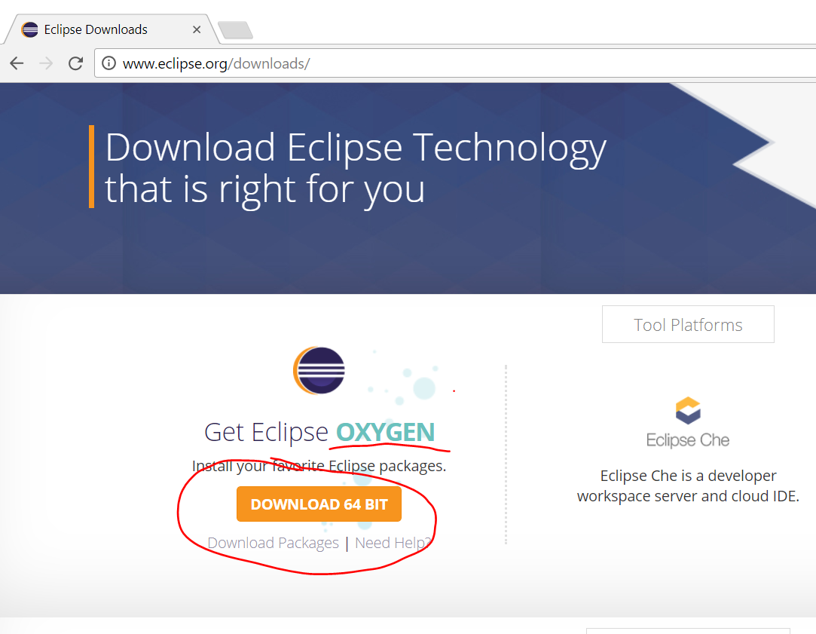

After the download, double click on the install exe such as “eclipse-inst-win64.exe”.

During the install, select “Eclipse IDE for Java EE Developers”. Use the default in almost all the cases, except the default workspace location (the default works but is not convenient)

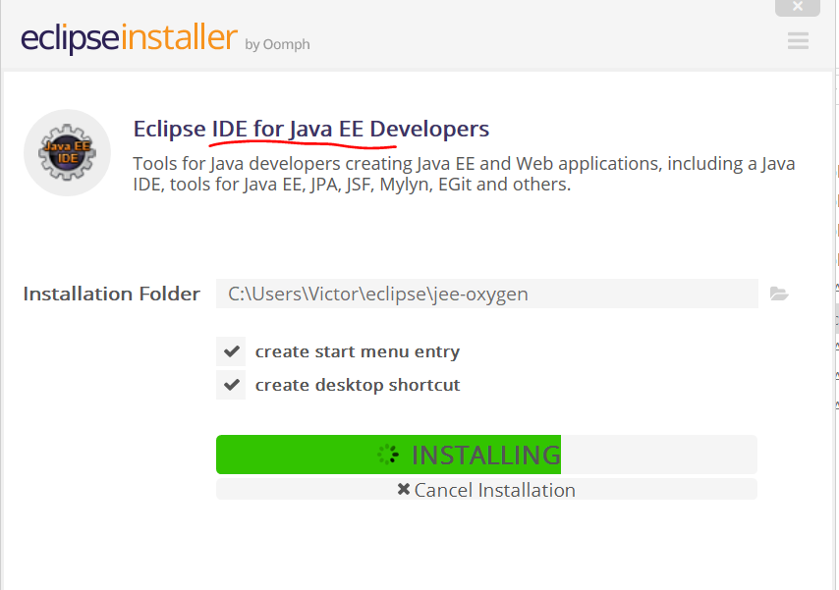

1. **Launch Eclipse**

Start the Eclipse. It will prompt you for the workspace (which the folder to save your program). The suggestion is to create a convenient location that you can remember for workspace such as C:\FIRST2018LV\OxgenWorkspace. The default workspace location is hard to remember.

Default workspace path is like:

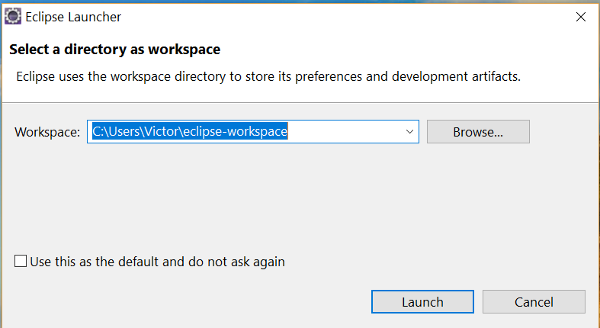

Click on Browse button to change a new folder that you can remember:

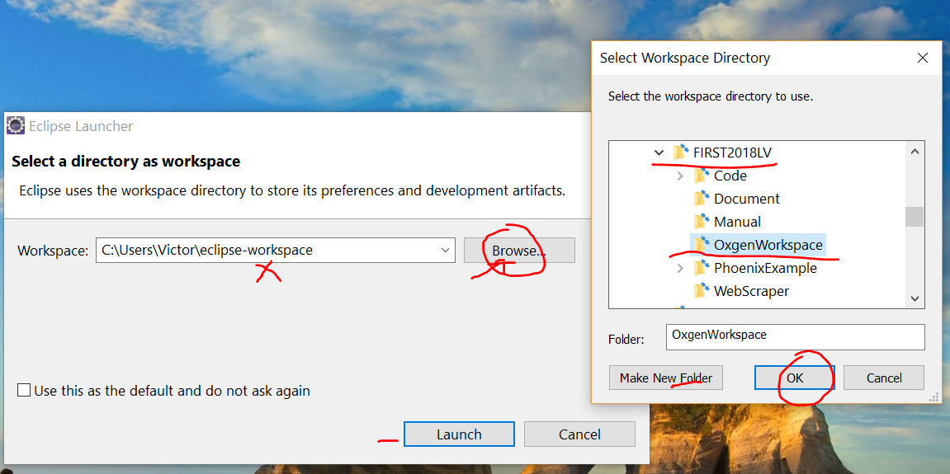

The final workspace:

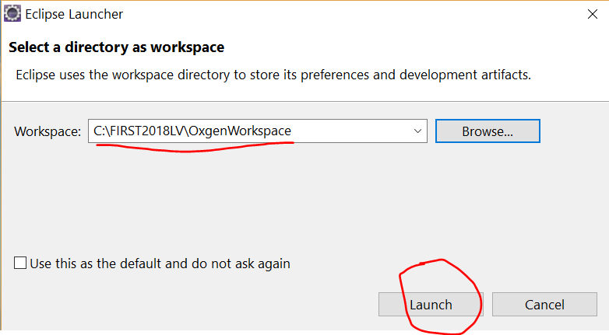

Click on “Launch” button to launch the eclipse:

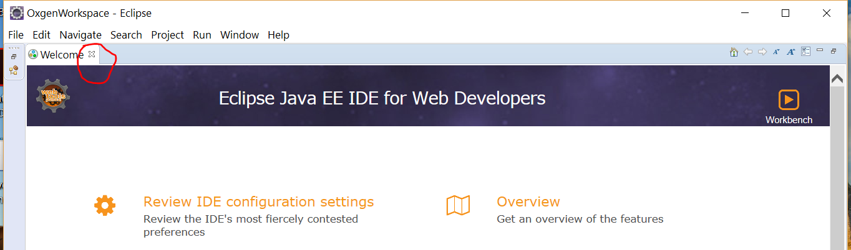

You can either close the Welcome page, or go through some tutorials in Welcome page.

1. **Create Java Project**

You need create a Java project first to contain (group) your programs in a subfolder. Click on File --> New --> Other…

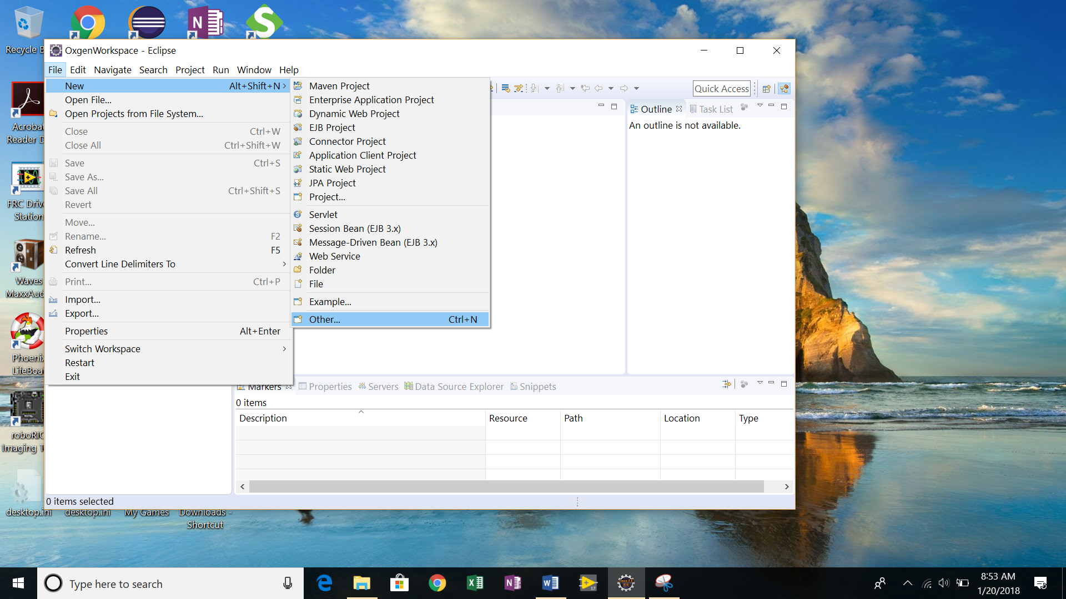

Select “Java Project” in next screen, click on “Next” button

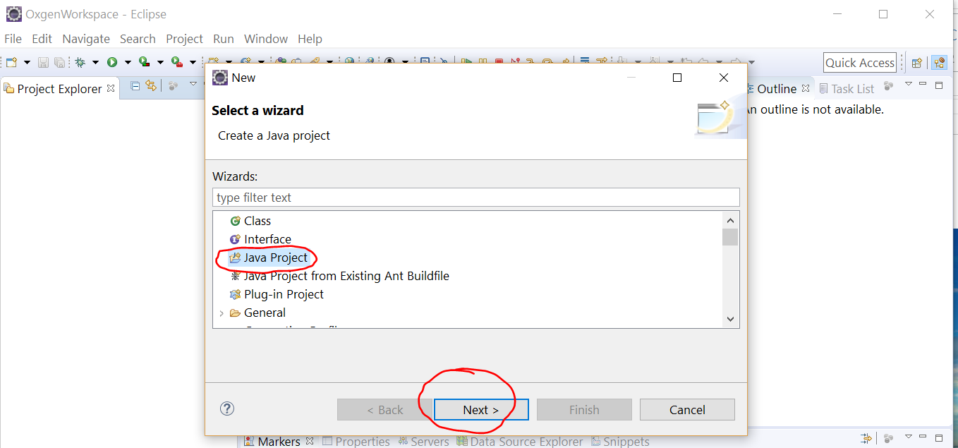

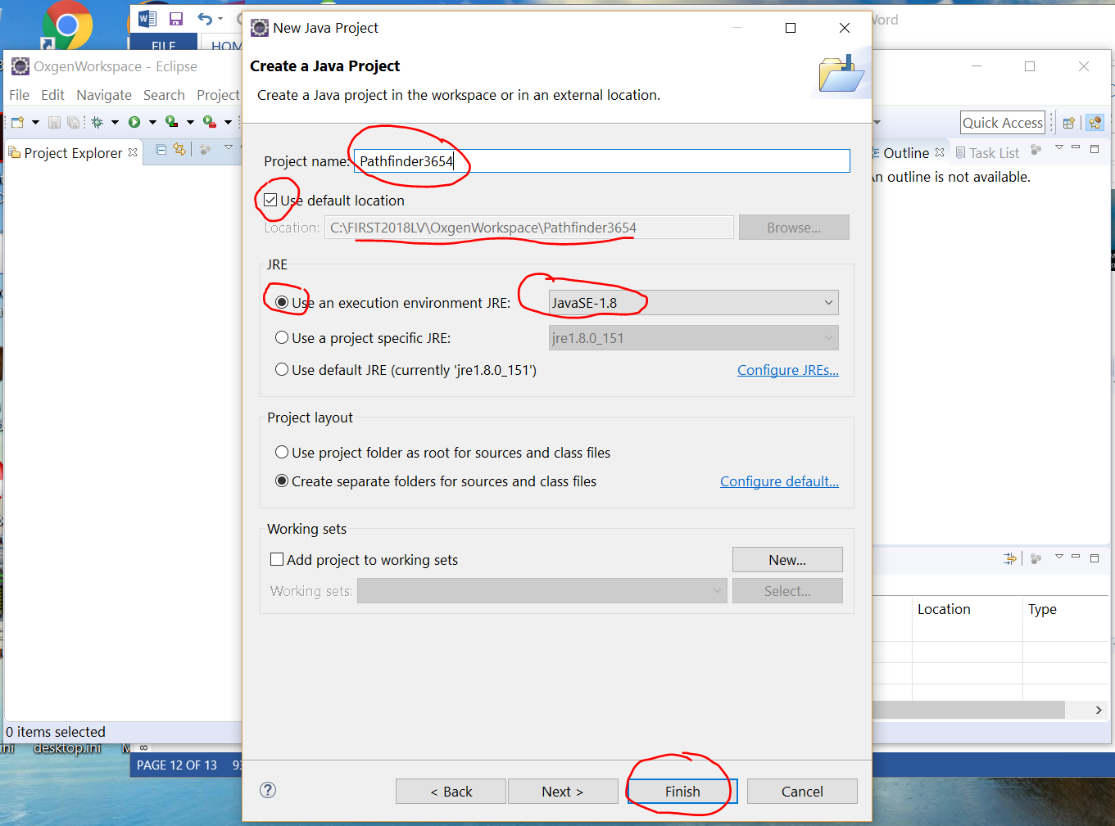

Type in “Pathfinder3654” in project name field. Double check “JavaSE-1.8” is the value in “Use an execution environment JRE”. Click “Finish” button.

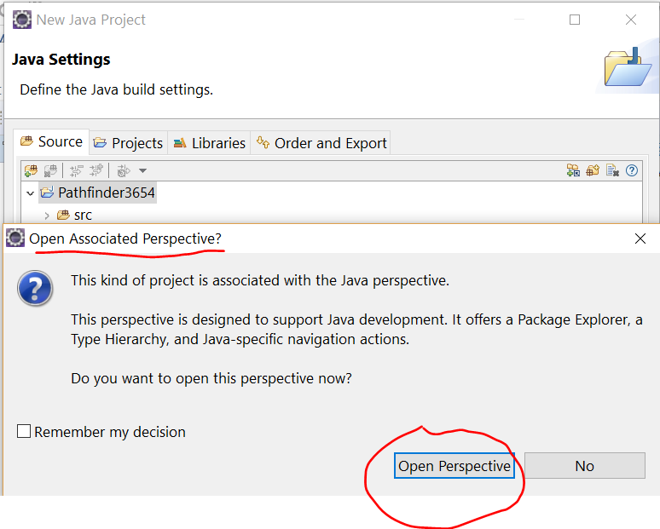

Click on “Open Perspective” to continue. (“Perspective” means in which viewpoint you want to see this project. In this case, it is “Java”. If you want to debug the code line by line, it would be “Debug” perspective.)

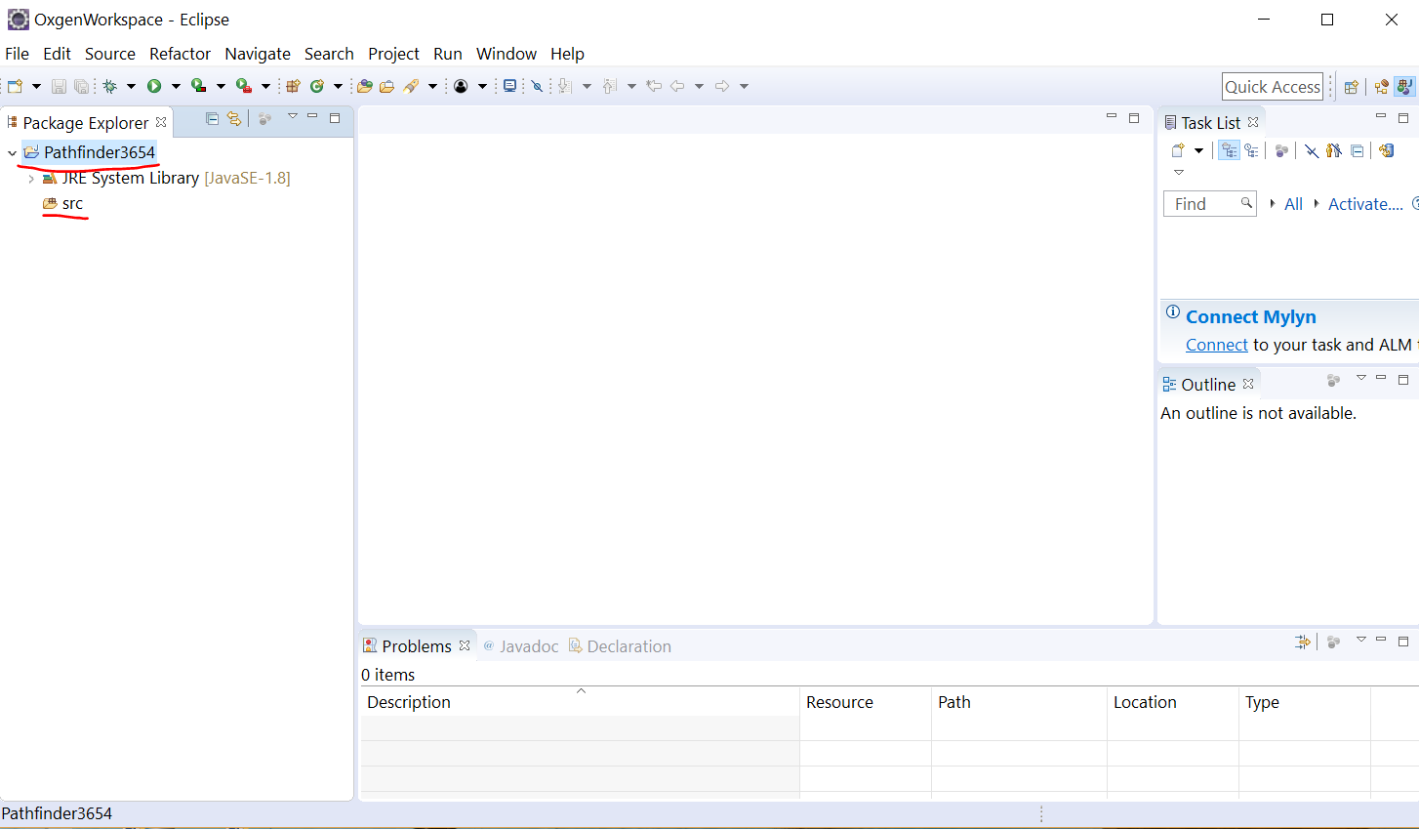

You will see the new project “Pathfinder3654” and an empty source code folder “src”.

1. **Create Your Own Program**

Now you can create your own program to do the actual work. We will create a java program called “Tank.java” to reflect our Tank style driving.

Right click on “src” folder, New 🡪 Class

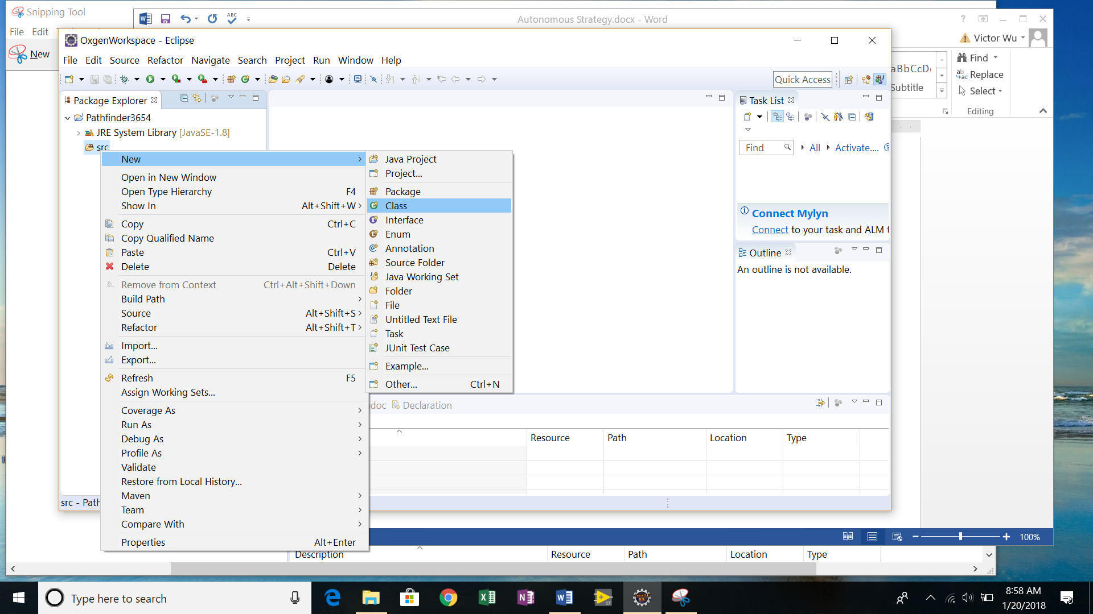

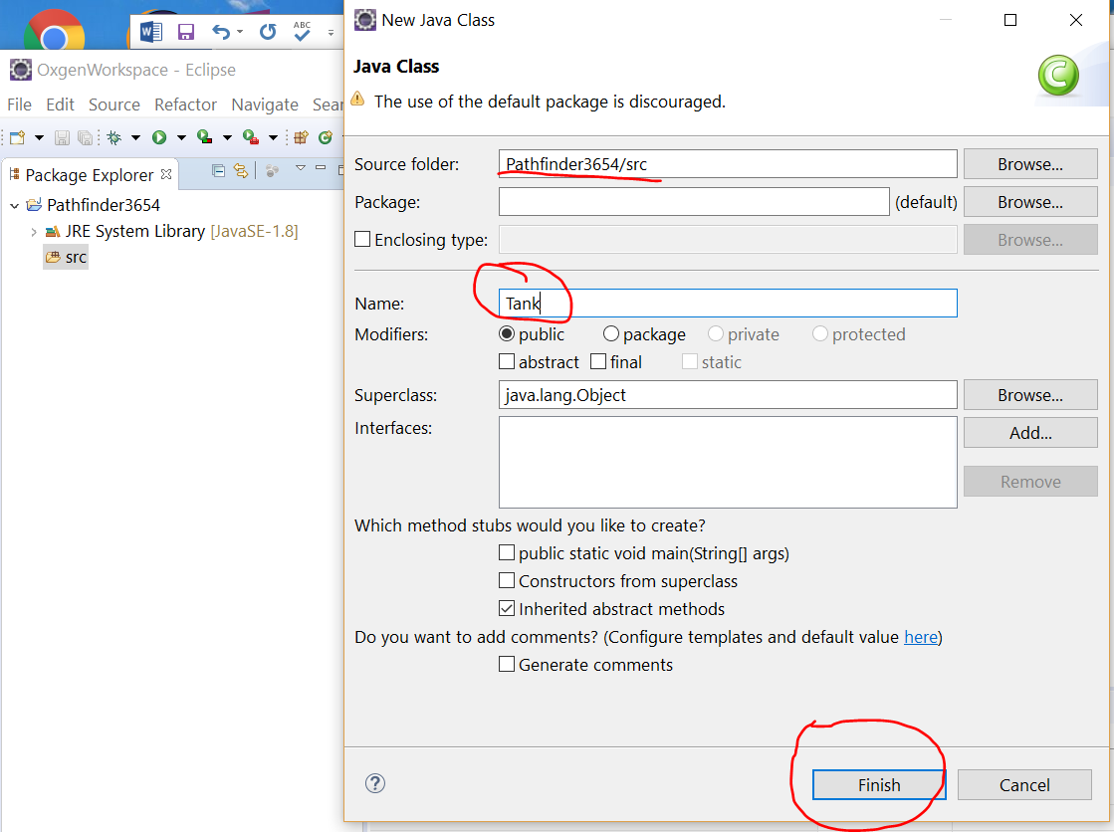

In Java Class screen, type in “Tank” in Name field. Notice that the Source Folder has the value we want. Click on “Finsih” button.

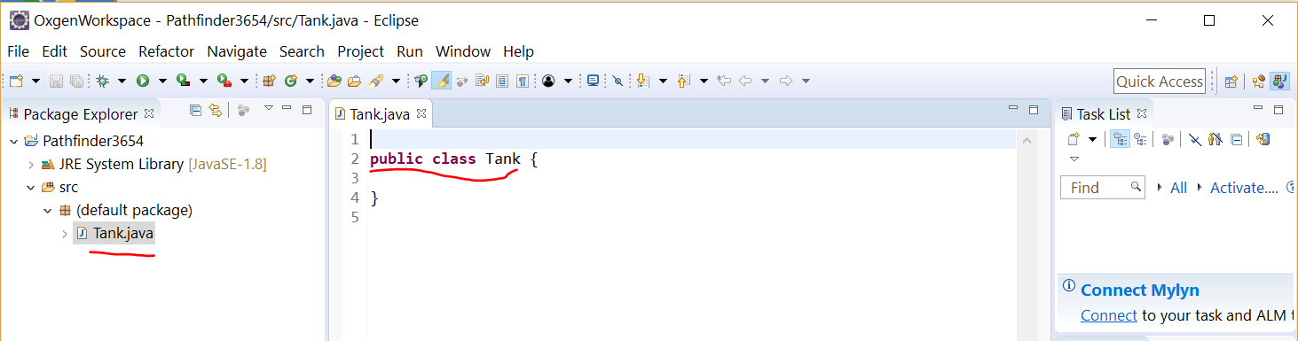

The “Tank.java” will open on the main panel. A new file “Tank.java” will appear under “src” folder on the left panel.

Before we add any code to Tank.java, we need import the Jaci’s Pathfinder library into the project in order to create the motion profile trajectory file.

1. **Import Jaci’s Pathfinder Library into Project**

Download the compiled Jaci’s Pathfinder library if you have not done so. The url is:

<https://github.com/JaciBrunning/Pathfinder/releases/tag/1.5> then select “[Pathfinder-Java.jar](https://github.com/JaciBrunning/Pathfinder/releases/download/1.5/Pathfinder-Java.jar)” to download.

Note: 2016 or 2017 is the last release of the library from Jaci. The code then merged into WPILib. This is older but simpler version of 1.5 without additional C library. After 2018, 2019, there is a newer version Pathfinder-Java-1.8.jar with some bug fix but requires addition library. The whole package of files can be found in wpilib\user\java\lib from <https://github.com/FRCTeam3654/2021prod_robot/tree/master/documentations/Pathfinder_MotionProfile>.

Normally the files are copied to a folder such as C:\Pathfinder\wpilib\user\java\lib.

Move the downloaded file “Pathfinder-Java.jar” to a safe folder such as “C:\Pathfinder” for project use.

In Eclipse with Pathfinder3654 project open, right click on the project name “Pathfinder3654” on the left panel, select “Properties”:

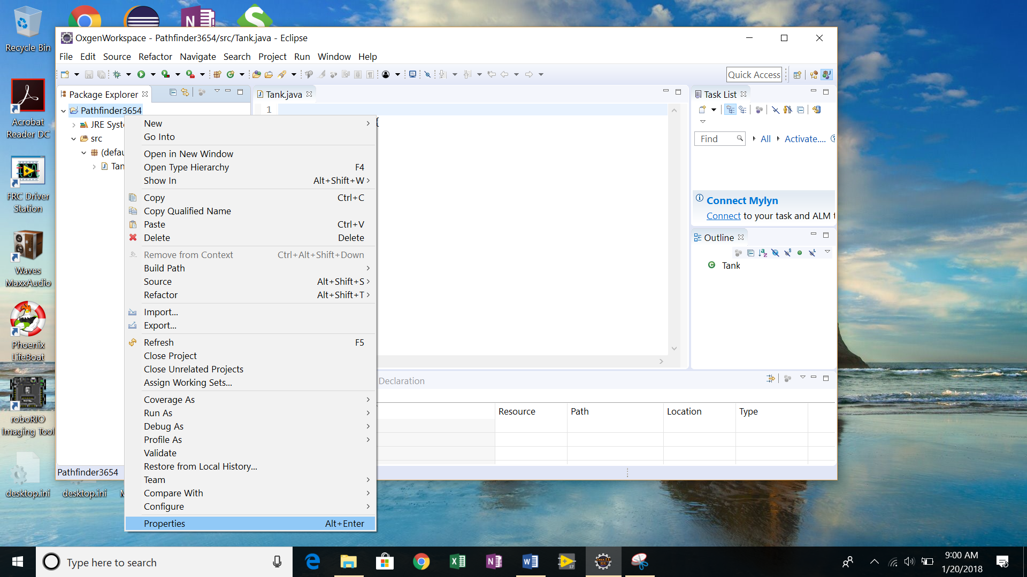

Remember how to get to the project’s Properties page. You will use it often.

At the project’s properties page, click on “Java Build Path” on the left panel, select “Libraries” tab on the right panel.

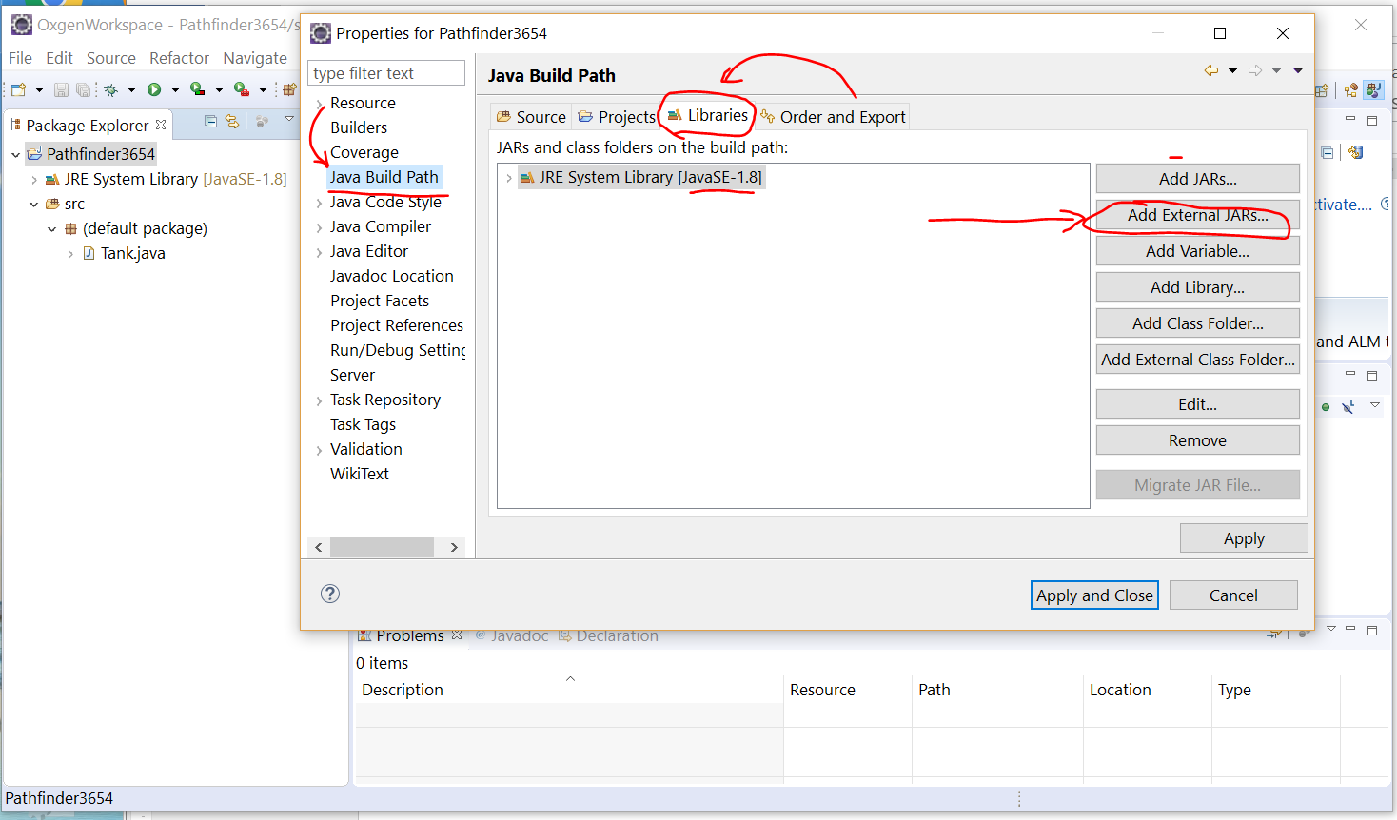

Click on “Add External JARs…”

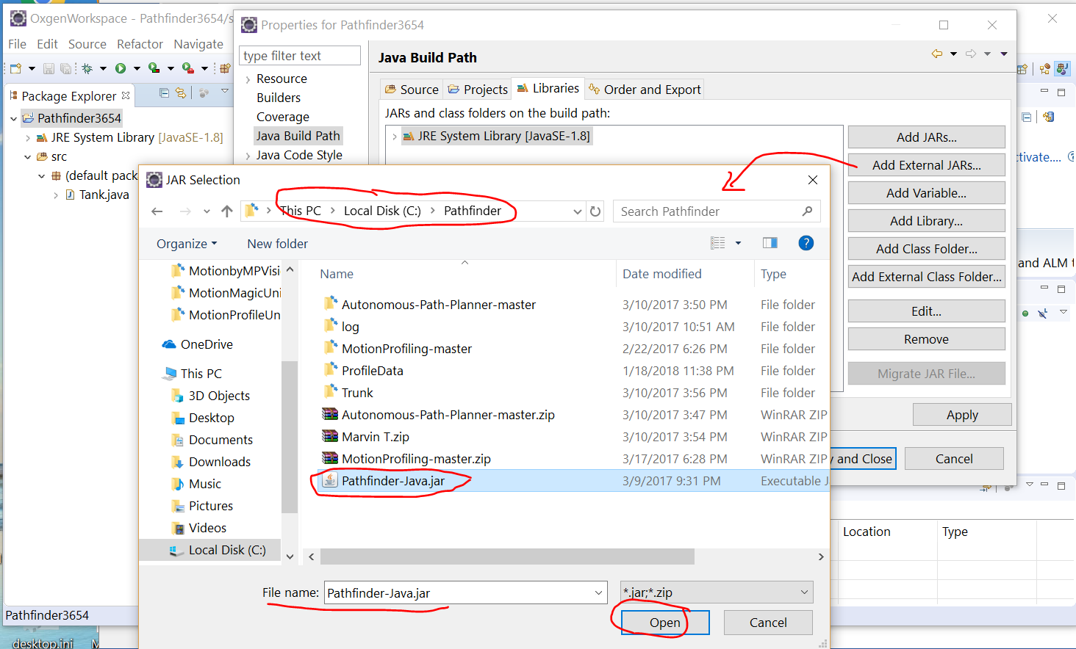

In the next screen, go to the folder where “Pathfinder-Java.jar” is located (you just downloaded it). Click on “Open” button.

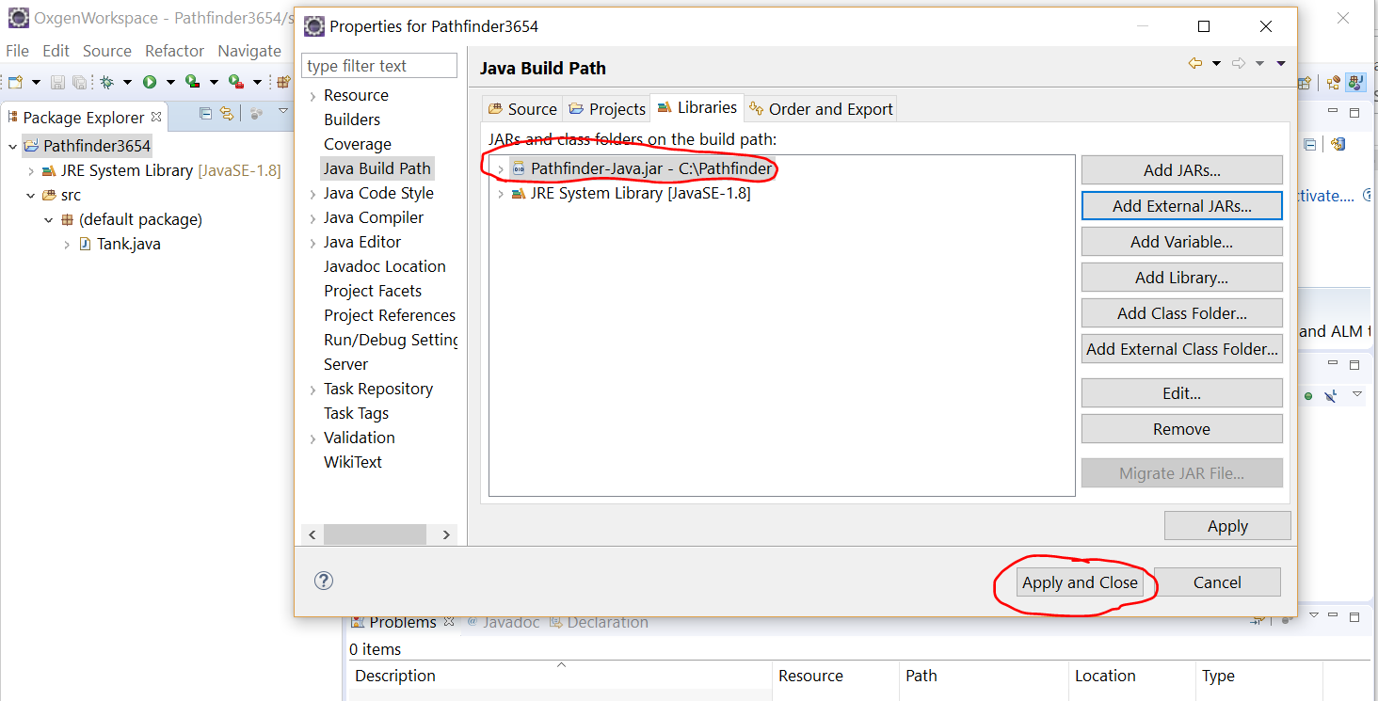

You will notice that “Pathfinder-Java.jar” appears in the main panel.

Click on “Apply and Close” button. You should see the empty “Tank.java” in main panel. We will add the real code in this file next.

1. **Copy and Modify Tank.java Source Code**

You can copy the content of the attached “Tank.java” into Eclipse’s Tank.java.



The source files can be found in <https://github.com/FRCTeam3654/2021prod_robot/tree/master/documentations/Pathfinder_MotionProfile/Pathfinder3654/src>

Note that there are two versions of files: tank.java generate the path without angles. TankArc.java generates the path with angle so it can be used both distance sensor and pigeon to control the robot. Normally TankArc.java is preferred.

The following is the screenshot of the file “TankArc.java”:

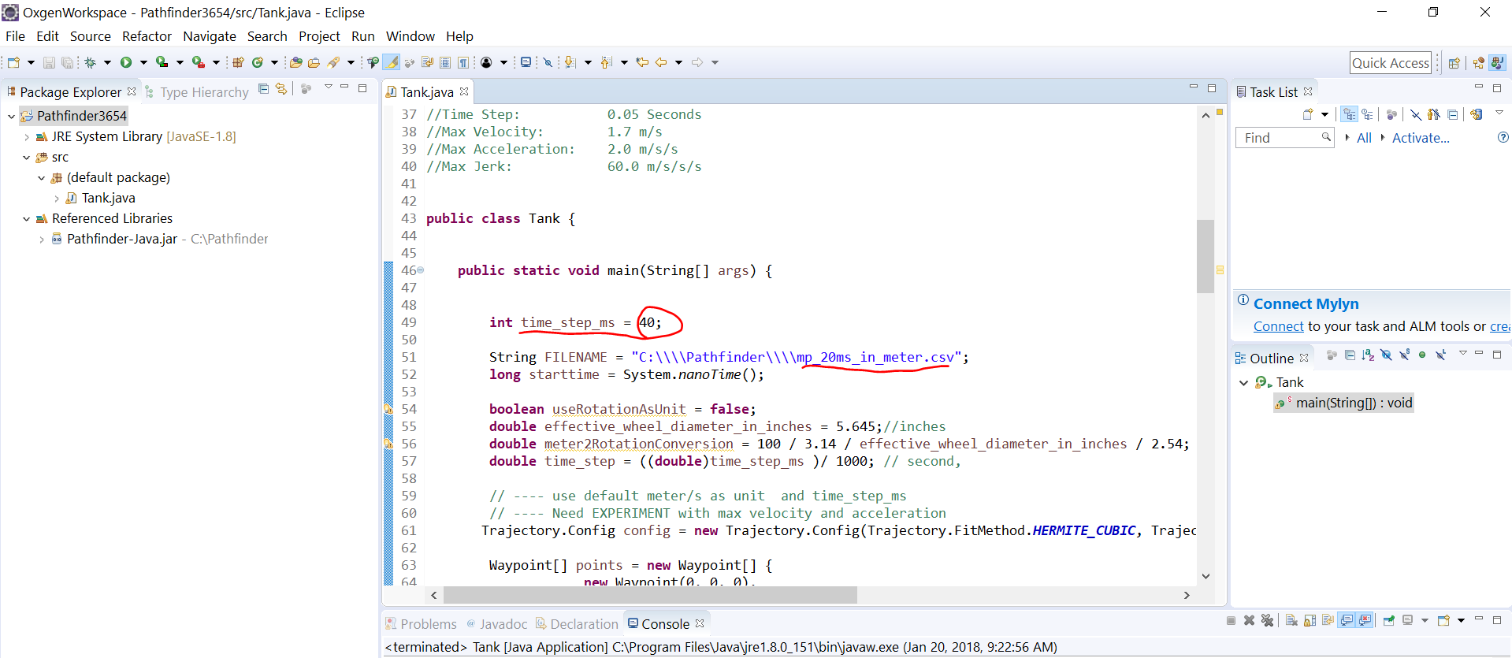

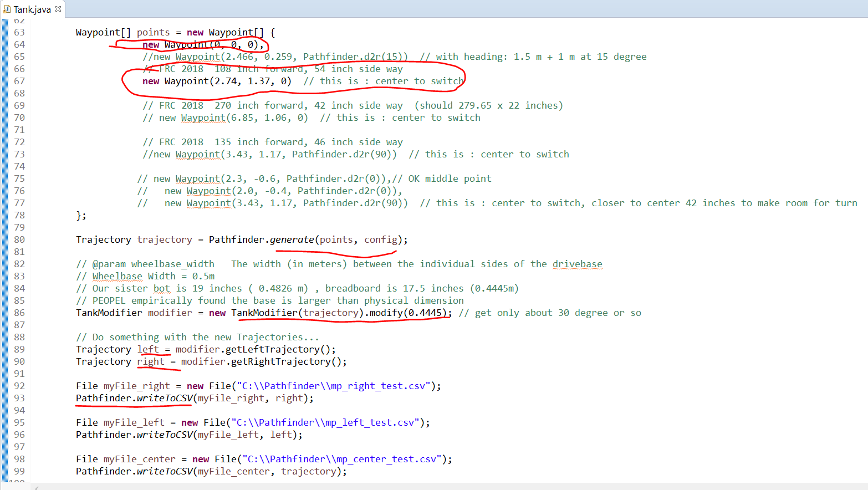

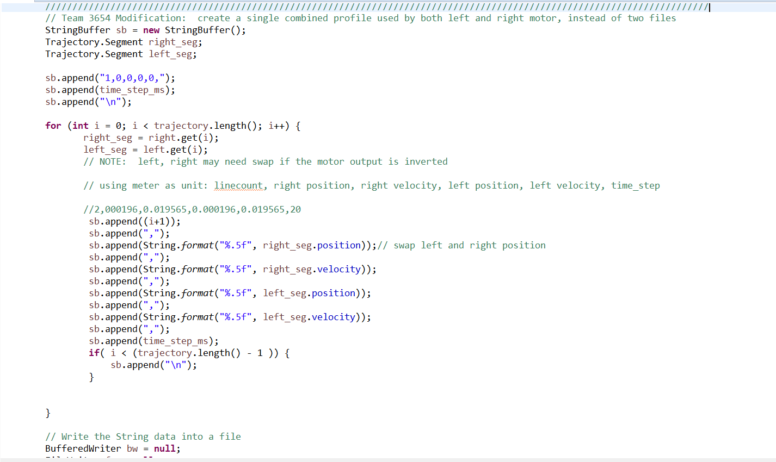

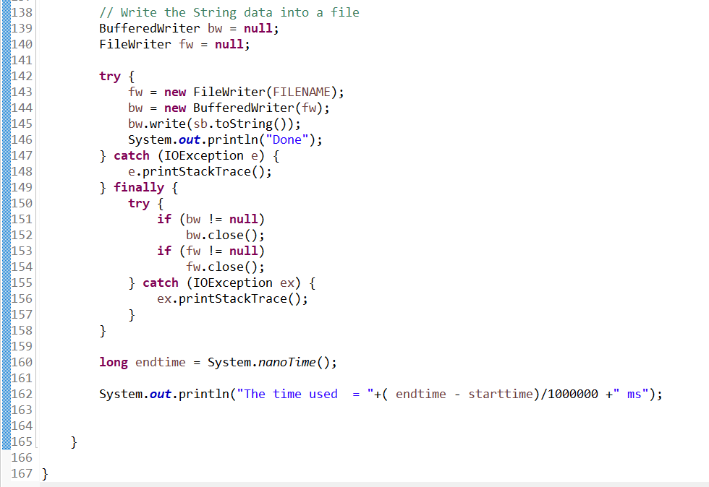

You can study the source code and modify some of the value for your need. In the sample code which mimic the move from the center to the switch: moving forward 2.74 meter and to the right 1.37 meter.

The trajectory file is saved to the folder C:\Pathfinder with file name “mp_20ms_in_meter.csv”. Several other files are generated for debugging/displaying purpose: “mp_center_test.csv”,” mp_left_test.csv”,” mp_right_test.csv”.

Once you have changed the parameter to your need, you can generate the profile file now.

1. **Generate Motion Profile Trajectory File**

Right click on anywhere in the main panel, select “Run As” 🡪 “Java Application”.

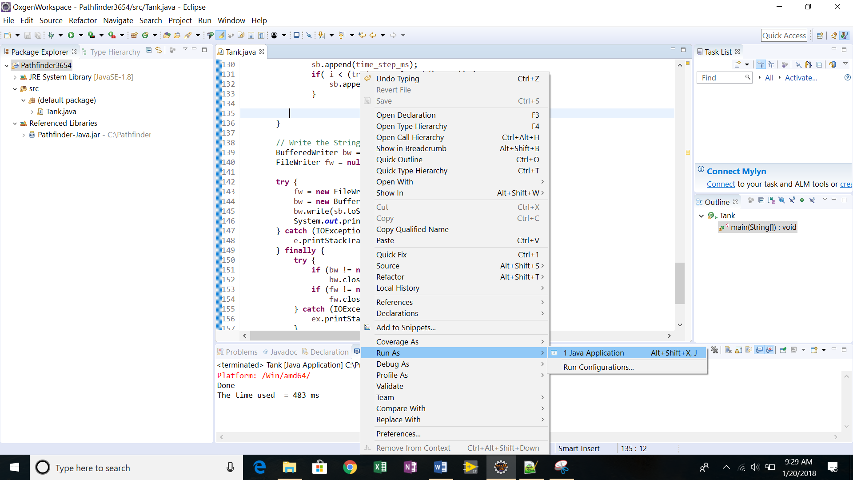

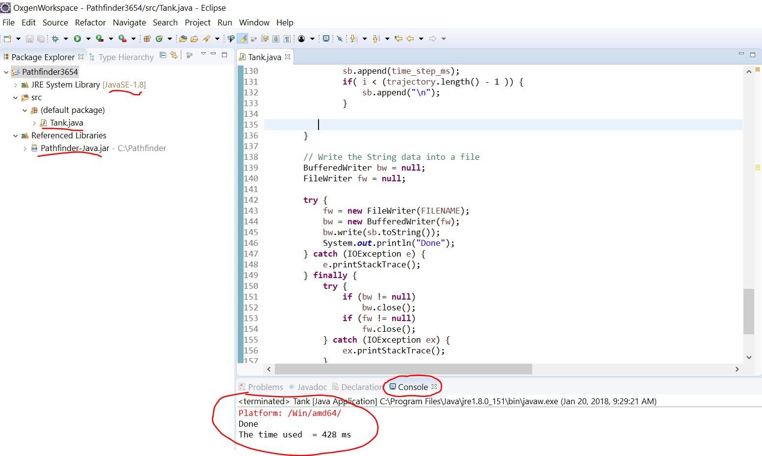

You will see the message in Console panel in the bottom.

You can verify the generated files by opening Window’s Explorer and checking the files in folder “C:\Pathfinder”.

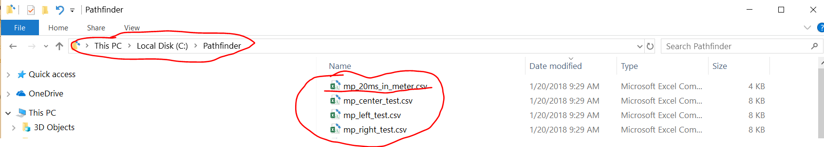

1. **Plot the Path**

This step is **optional,** but it is fun to see how your robot is supposed to move visually.

Open the above generated file “mp_center_test.csv” in Excel. Select the column “x”, “y”.

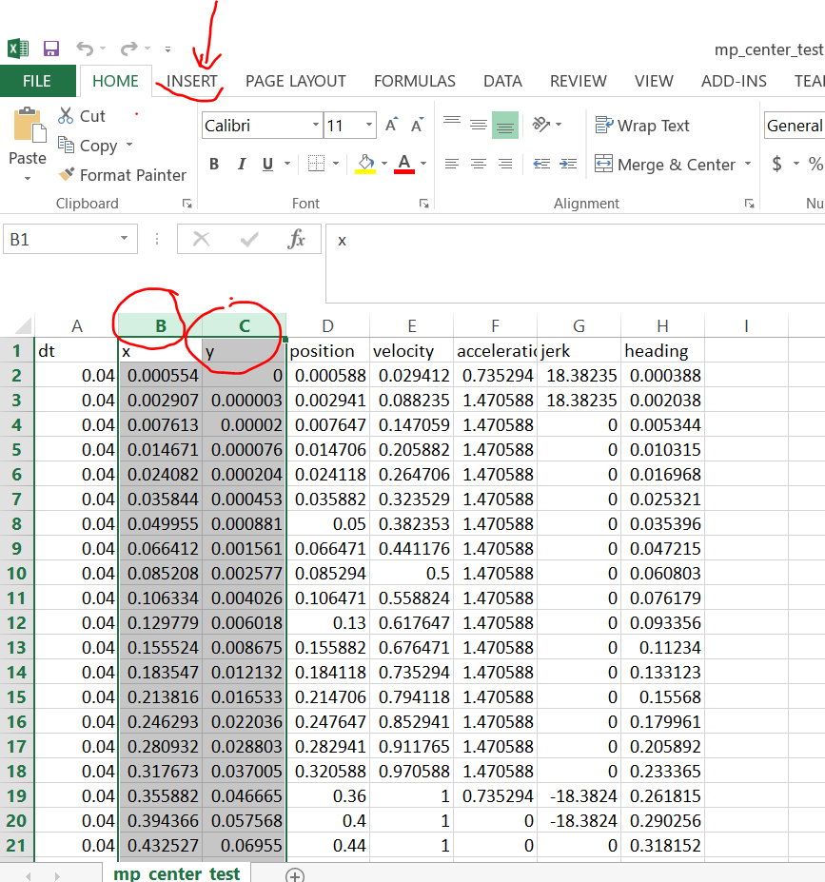

Select “INSERT” tab, go to “Charts” section, select “Scatter” chart, select the a graph with lines like the second one. You will see the robot path plotted in the a graph.

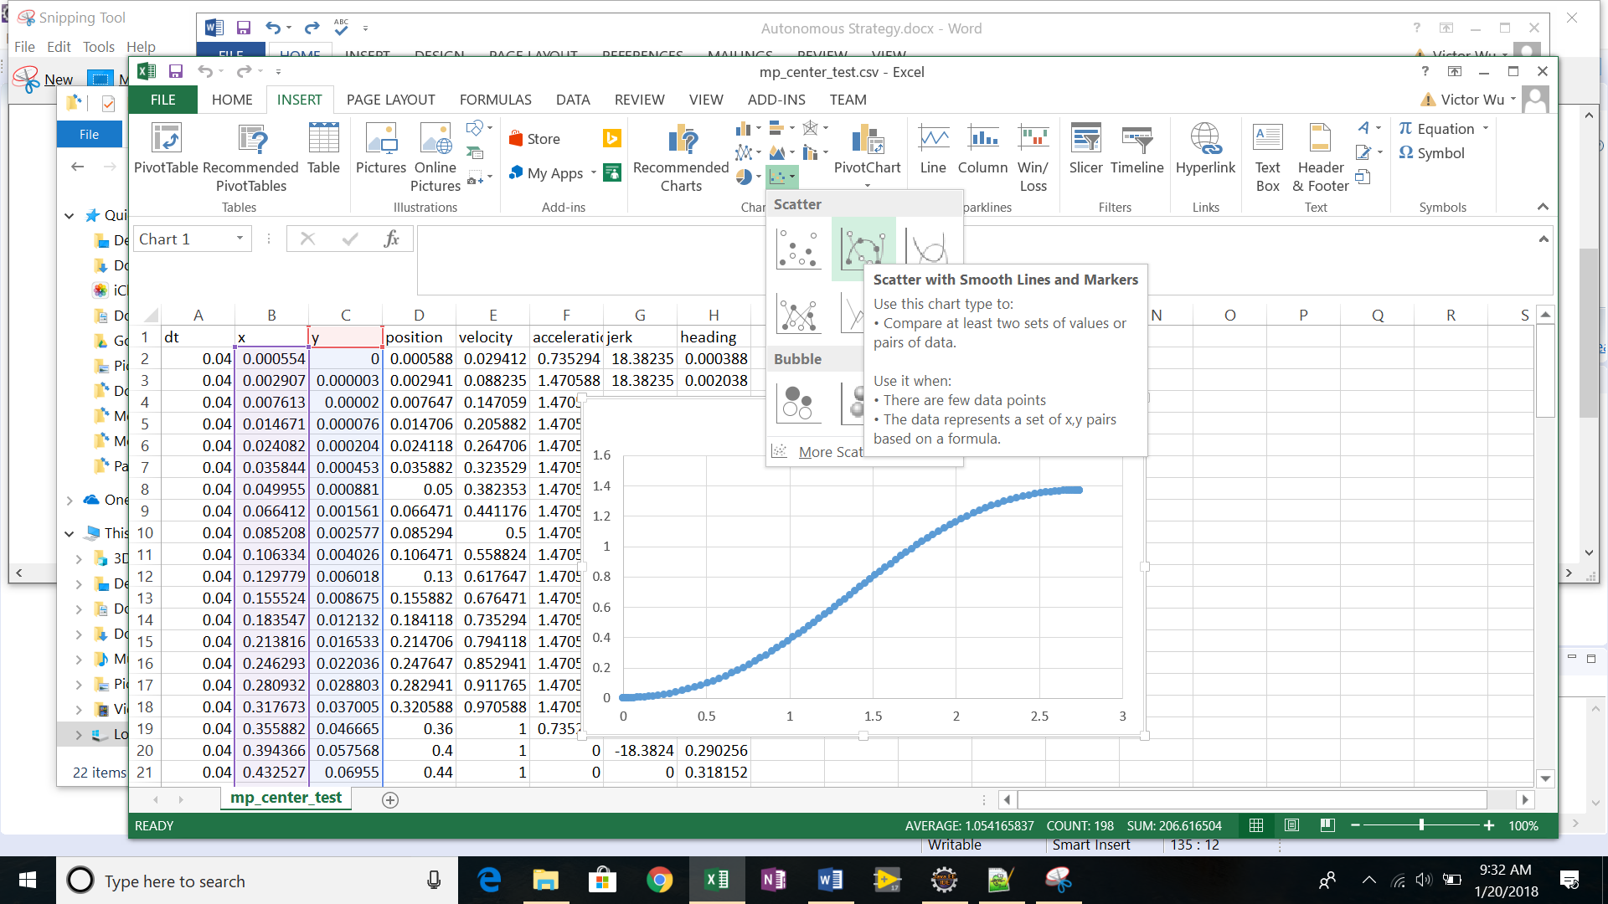

1. **Upload the Trajectory File into RoboRIO**

You will need WinSCP to upload the trajectory file “mp_20ms_in_meter.csv” into RoboRIO’s. You can download the WinSCP from <https://winscp.net/eng/download.php> if you have not installed it.

The robot need be turned on, and is connected to PC via Ethernet cable. You can use USB cable too but you need modify the RoboRIO host name to 172.22.11.2 instead of roborio-3654-frc.local.

Open WinSCP, use “roborio-3654-frc.local” as Host name, “SCP” as File protocol, and “22” as Port number. User name is “admin”, nothing in Password.

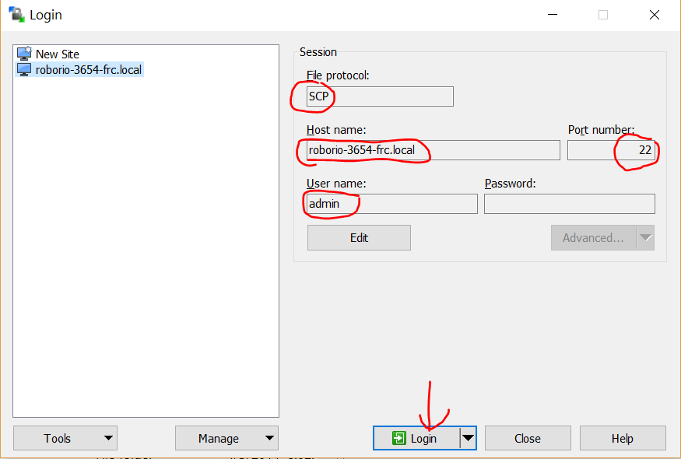

Click “Login” button. After login, at RoboRIO side, got to /home/lvuser folder if you are not at this folder.

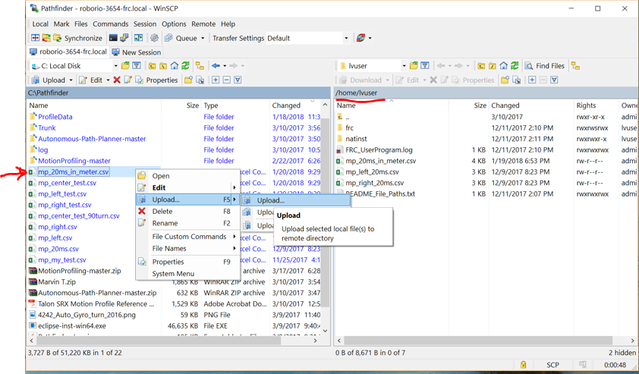

You can select the file in your pc you want to upload and upload it to /home/lvuser in RoboRIO.

Once the trajectory file is in RoboRIO, you are ready to use LabView to read the file to control the robot.